Kubernetes Tutorial

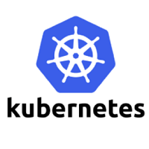

What is Kubernetes?

**Kubernetes** is also known as **'k8s'.** This word comes from the Greek language, which means a **pilot** or **helmsman**. It is an important Devops Deployment Tool.   
**Kubernetes** is an extensible, portable, and open-source platform designed by **Google** in **2014**. It is mainly used to automate the deployment, scaling, and operations of the container-based applications across the cluster of nodes. It is also designed for managing the services of containerized apps using different methods which provide the scalability, predictability, and high availability.

It is actually an enhanced version of '**Borg**' for managing the long-running processes and batch jobs. Nowadays, many cloud services offer a Kubernetes-based infrastructure on which it can be deployed as the platform-providing service. This technique or concept works with many container tools, like **docker,** and follows the client-server architecture.

Key Objects of Kubernetes

Following are the key objects which exist in the Kubernetes:

**Pod** of Java

It is the smallest and simplest basic unit of the Kubernetes application. This object indicates the processes which are running in the cluster.

**Node**

A **node** is nothing but a single host, which is used to run the virtual or physical machines. A node in the Kubernetes cluster is also known as a minion.

**Service**

A **service** in a Kubernetes is a logical set of pods, which works together. With the help of services, users can easily manage load balancing configurations.

**ReplicaSet**

A **ReplicaSet** in the Kubernetes is used to identify the particular number of pod replicas are running at a given time. It replaces the replication controller because it is more powerful and allows a user to use the "set-based" label selector.

**Namespace**

**Kubernetes** supports various virtual clusters, which are known as namespaces. It is a way of dividing the cluster resources between two or more users.

Features of Kubernetes

Following are the essential features of Kubernetes:



1. **Pod:** It is a deployment unit in Kubernetes with a single Internet protocol address.
2. **Horizontal Scaling:** It is an important feature in the Kubernetes. This feature uses a **HorizontalPodAutoscalar** to automatically increase or decrease the number of pods in a deployment, replication controller, replica set, or stateful set on the basis of observed CPU utilization.
3. **Automatic Bin Packing:** Kubernetes helps the user to declare the maximum and minimum resources of computers for their containers.
4. **Service Discovery and load balancing:** Kubernetes assigns the IP addresses and a Name of DNS for a set of containers, and also balances the load across them.
5. **Automated rollouts and rollbacks:** Using the rollouts, Kubernetes distributes the changes and updates to an application or its configuration. If any problem occurs in the system, then this technique rollbacks those changes for you immediately.
6. **Persistent Storage:** Kubernetes provides an essential feature called '**persistent storage'** for storing the data, which cannot be lost after the pod is killed or rescheduled. Kubernetes supports various storage systems for storing the data, such as **Google Compute Engine's Persistent Disks (GCE PD) or Amazon Elastic Block Storage (EBS).** It also provides the distributed file systems: **NFS or GFS**.
7. **Self-Healing:** This feature plays an important role in the concept of Kubernetes. Those containers which are failed during the execution process, Kubernetes restarts them automatically. And, those containers which do not reply to the user-defined health check, it stops them from working automatically.

Kubernetes Architecture

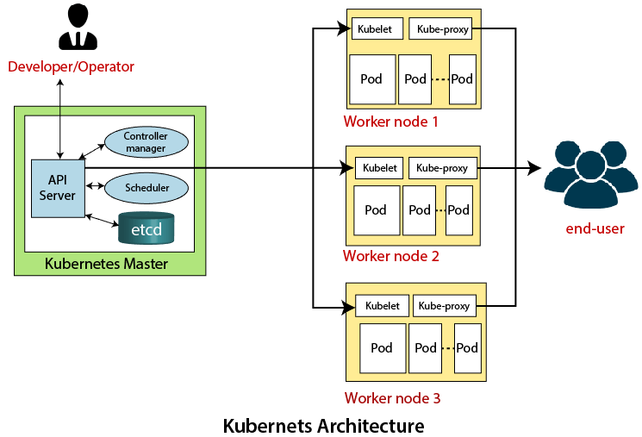

The architecture of Kubernetes actually follows the client-server architecture. It consists of the following two main components:

1. Master Node (Control Plane)
2. Slave/worker node

Master Node or Kubernetes Control Plane

The master node in a Kubernetes architecture is used to manage the states of a cluster. It is actually an entry point for all types of administrative tasks. In the Kubernetes cluster, more than one master node is present for checking the fault tolerance.

Following are the four different components which exist in the Master node or Kubernetes Control plane:

1. API Server
2. Scheduler
3. Controller Manager
4. ETCD

**API Server**

The Kubernetes API server receives the REST commands which are sent by the user. After receiving, it validates the REST requests, process, and then executes them. After the execution of REST commands, the resulting state of a cluster is saved in '**etcd**' as a distributed key-value store.

**Scheduler**

The scheduler in a master node schedules the tasks to the worker nodes. And, for every worker node, it is used to store the resource usage information.  
In other words, it is a process that is responsible for assigning pods to the available worker nodes.

**Controller Manager**

The Controller manager is also known as a controller. It is a daemon that executes in the non-terminating control loops. The controllers in a master node perform a task and manage the state of the cluster. In the Kubernetes, the controller manager executes the various types of controllers for handling the nodes, endpoints, etc.

**ETCD**

It is an open-source, simple, distributed key-value storage which is used to store the cluster data. It is a part of a master node which is written in a GO programming language.

Now, we have learned about the functioning and components of a master node; let's see what is the function of a slave/worker node and what are its components.

Worker/Slave node

The Worker node in a Kubernetes is also known as minions. A worker node is a physical machine that executes the applications using pods. It contains all the essential services which allow a user to assign the resources to the scheduled containers.

Following are the different components which are presents in the Worker or slave node:

**Kubelet**

This component is an agent service that executes on each worker node in a cluster. It ensures that the pods and their containers are running smoothly. Every **kubelet** in each worker node communicates with the master node. It also starts, stops, and maintains the containers which are organized into pods directly by the master node.

**Kube-proxy**

It is a proxy service of Kubernetes, which is executed simply on each worker node in the cluster. The main aim of this component is request forwarding. Each node interacts with the Kubernetes services through **Kube-proxy**.

**Pods**

A **pod** is a combination of one or more containers which logically execute together on nodes. One worker node can easily execute multiple pods.

Installation of Kubernetes on Linux

The installation of Kubernetes on Linux is a straight forward process. Follow the below steps to install the Kubernetes. In the installation of Kubernetes, each step is mandatory.

**Step 1:** In this step, we have to update the necessary dependencies of a system using two commands.

The first command is used to get all the updates. Execute the following command in the terminal; it will ask to enter the system's password.

1. sudo apt-get update

**Output:**

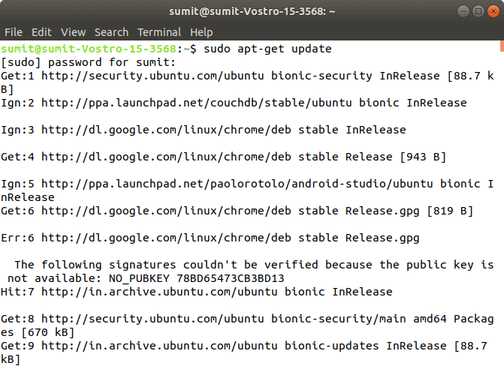

When the first command is successfully executed, type the following second command, which is used to make the repositories.

1. sudo apt-get install -y apt-transport-https

**Output:**

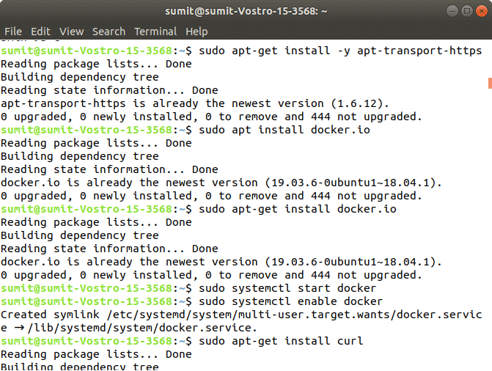

**Step 2:** After the above steps are successfully executed, we have to install the dependencies of docker in this step.

Type the following command to install the docker. In the installation process, we have to choose Y for confirmation of the installation.

1. sudo apt install docker.io

**Output:**

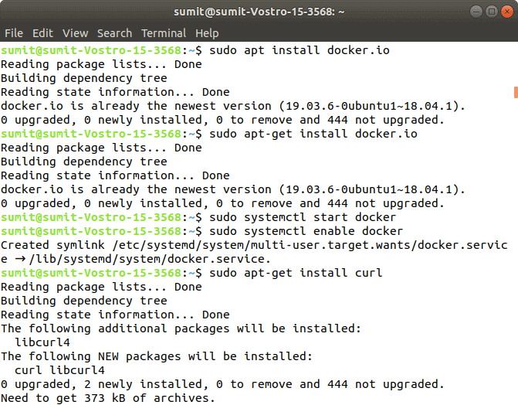

After installing the docker, we have to type the different two commands for starting and enabling the docker. Type the following first command, which starts the docker:

1. sudo systemctl start docker

Now, type the following second command, which enables the docker:

1. sudo systemctl enable docker

**Output:**

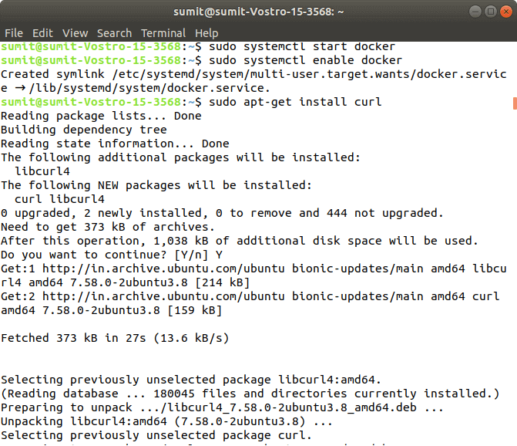

Now, we can check the version of docker by typing the following command:

1. Docker -version

**Output:**

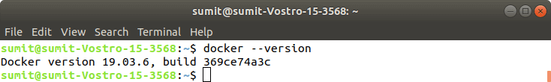

**Step 3:** After the successful execution of all the commands of the second step, we have to install the curl command. The curl is used to send the data using URL syntax.

Now, install the curl by using the following command. In the installation, we have to type Y.

1. sudo apt-get install curl

**Output:**

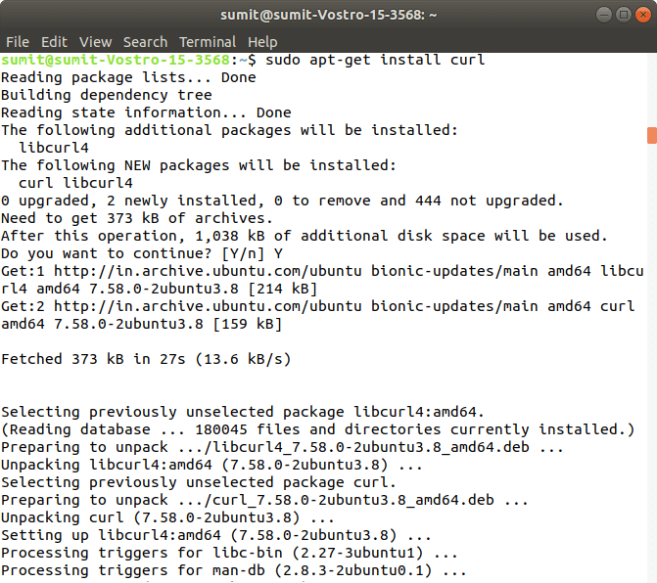

Now, we have to download the add package key for Kubernetes by the following command:

1. sudo curl -s https://packages.cloud.google.com/apt/doc/apt-key.gpg | sudo apt-key add

**Output:**

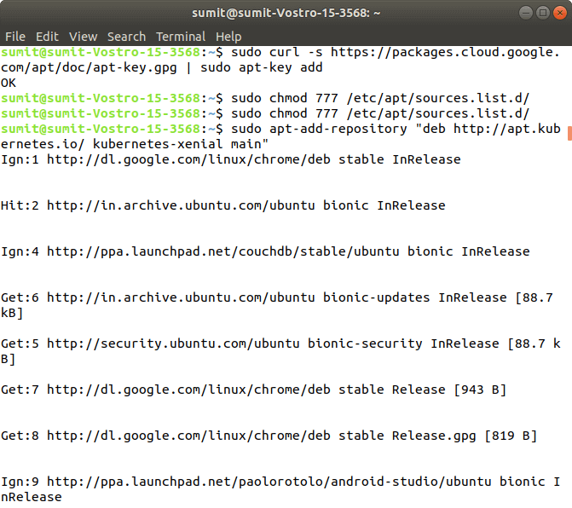

If you get an error from the above command, then it means your curl command is not successfully installed, so first install the curl command, and again run the above command.

Now, we have to add the Kubernetes repositories by the following command:

1. sudo apt-add-repository "deb http://apt.kubernetes.io/ kubernetes-xenial main"

**Output:**

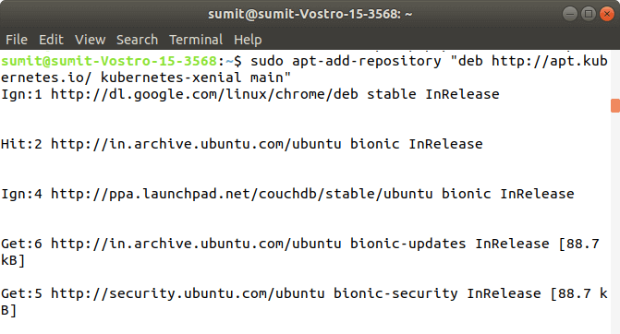

After the successful execution of the above command, we have to check any updates by executing the following command:

1. sudo apt-get update

**Output:**

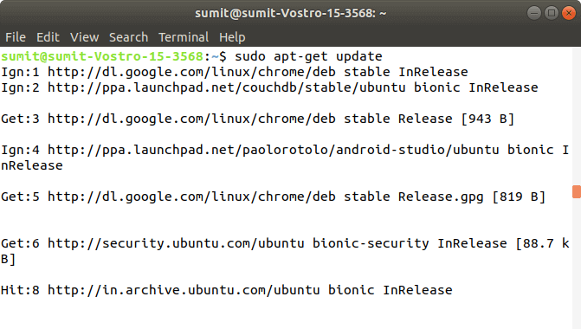

**Step 4:** After the execution of the above commands in the above steps, we have to install the components of Kubernetes by executing the following command:

1. sudo apt-get install -y kubelet kubeadm kubectl kubernetes-cni

**Output:**

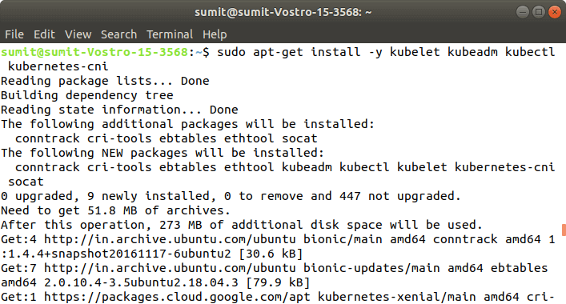

**Step 5:** After the above installation is done, we have to initialize the kubeadm by executing the following command. The following command disables the swapping on other devices:

1. sudo swapoff -a

**Output:**

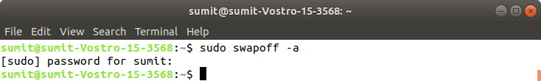

Now, we have to initialize the kubeadm by executing the following command:

1. sudo kubeadm init

**Output:**

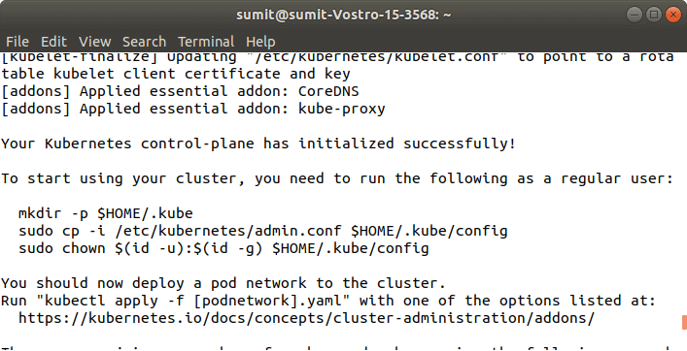

**Step 6:** After the above command is successfully executed, we have to run the following commands, which are given in the initialization of kubeadm. These commands are shown in the above screenshot. The following commands are used to start a cluster:

1. mkdir -p $HOME/.kube
2. sudo cp -i /etc/kubernetes/admin.conf $HOME/.kube/config
3. sudo chown $(id -u):$(id -g) $HOME/.kube/config

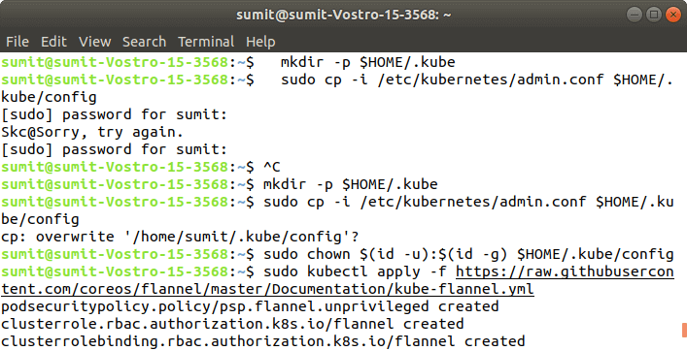  
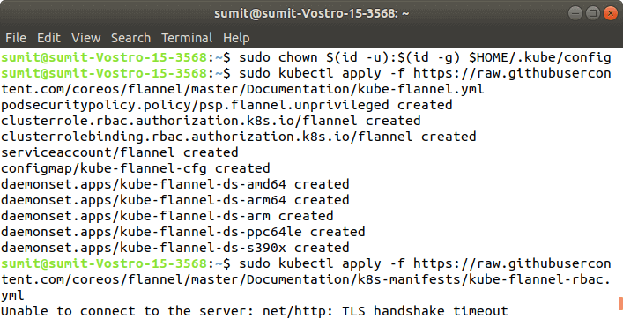

**Output:**

**Step 7:** In this step, we have to deploy the paths using the following command:

1. sudo kubectl apply -f https://raw.githubusercontent.com/coreos/flannel/master/Documentation/kube-flannel.yml

**Output:**

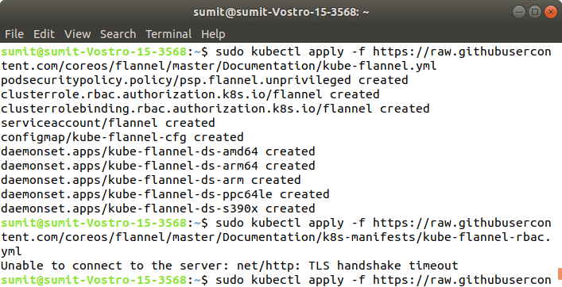

**Step 8:** After the execution of the above command, we have to run the following command to verify the installation:

1. sudo kubectl get pods --all-namespaces

**Output:**

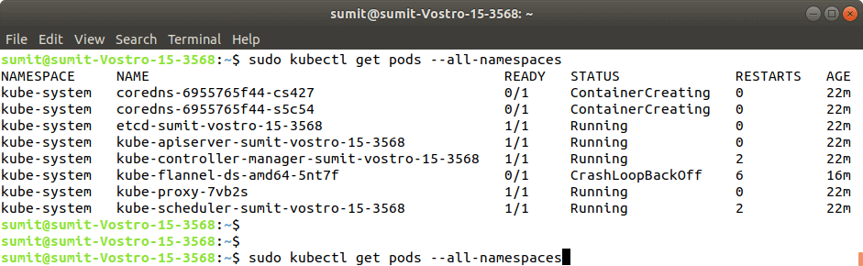

If the output is displayed as shown in the above screenshot. It means that the Kubernetes is successfully installed on our system.